**HW3 due by Monday Feb. 24 by 11:59 PM**

The create_expense.sql script (you can find it on Blackboard in the Homework 3 folder) creates a database which contains the 7 tables described below. The data contains a tracking system for expense reports filed by employees at a manufacturing company. **Please watch the Panopto “video 5 for HW3” before doing this Homework 3.**

**If you use Chat GPT, please use the “Share” button (looks like ‘upward arrow’) in the right corner of ChatGPT chat, and ‘copy link’ and share the link to that chat in this Word document and briefly explain how you used it for your Homework (for each HW question if you used it). No points off will be taken for using ChatGPT (it is allowed to use it for Homework) but you are required to share the link to a chat if you used it.**

**More information on how to share a chat here:** <https://help.openai.com/en/articles/7925741-chatgpt-shared-links-faq>

|  |  |
| --- | --- |
| **employees** | **Field Description** |
| Ssn (pk) | Unique SSN ID# for employee |
| First_name | Employee first name |
| Last_name | Employee last_name |
| Dept (fk) | Dept ID# |
| Start_year | Year of employment |

|  |  |  |
| --- | --- | --- |
| **trips** | | **Field Description** |
| Employee (pk, fk) | | SSN of employee travelling |
| Trip_ID (pk) | | Unique Trip ID# |
| Start_date | | Start date of trip |
| End_date | | End date of trip |
| Reason_code (fk) | | Code for reason for trip |
|  | |  |
| **expenses** | **Field Description** | | |
| Employee (pk, fk)  Trip_id (pk, fk) | SSN of employee travelling  Unique Trip ID# | | |
| Expense_seq (pk) | Sequence# for expense report line item | | |
| Account_no (fk) | Account number for line item | | |
| Gross_amount | Gross dollar amount of line item | | |
| tax | Sales tax (if applicable) of line item | | |
|  |  | | |

|  |  |
| --- | --- |
| **dept_codes** | **Field Description** |
| Dept_ID (pk) | Dept ID# |
| Dept_name | Name of department |

|  |  |  |
| --- | --- | --- |
| **Reason_codes** | **Field Description** | |
| Reason_code (pk) | Reason ID# | |
| Reason_description | Description of reason for trip | |
|  |  | |
| **account_codes** | **Field Description** |
| Account_no (pk) | Account ID# |
| Account_description | Description of account |
| Account_type | Category of account |
| **reimbursements** | **Field Description** |
| Employee (pk, fk) | SSN of employee travelling |
| Trip_id (pk, fk) | Unique Trip ID# |
| Auditor | Auditor last name |
| Reimbursement_amount | Amount of reimbursement |
| Reimbursement_date | Date of reimbursement |

Please put all of your work into **this** **single Word doc**.

1. (60 points) Design and create a data warehouse for the Expense database. The decisions about which fields to include and how to aggregate the data are left to you. You do not need to include every single data point from the 7 tables given. Use your judgement as to what will be interesting/useful for the organization. But please make sure that you pull (combine) data from **at least four tables** and compute relevant aggregate statistics. Please see many examples from class lectures and you may adapt those codes for your purpose (for this dataset).

**Submit a screenshot of the first 25 rows of your data warehouse (paste into this Word document) and the SQL code that you used to create it. Please copy and paste your SQL code into this Word document.**

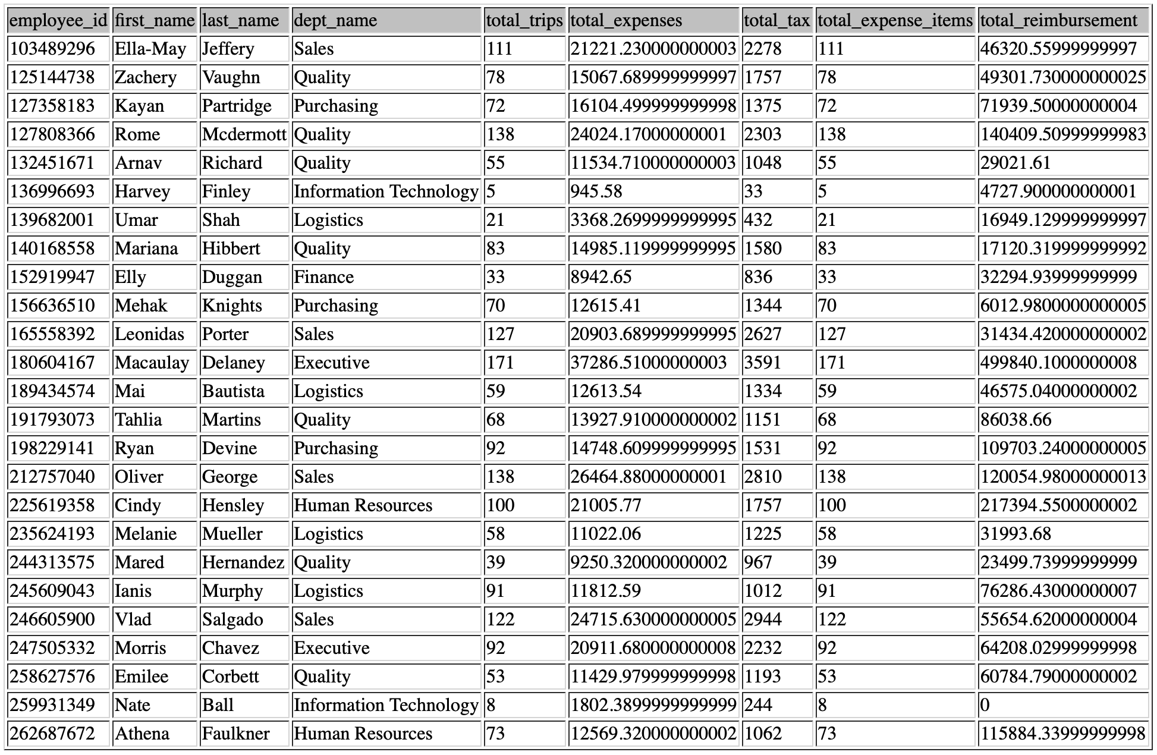

DROP TABLE IF EXISTS fact_expense_reports;

CREATE TABLE fact_expense_reports AS

SELECT

e.ssn AS employee_id,

e.first_name,

e.last_name,

d.dept_name,

COUNT(t.trip_id) AS total_trips,

SUM(ex.gross_amount) AS total_expenses,

SUM(ex.tax) AS total_tax,

COUNT(ex.expense_seq) AS total_expense_items,

SUM(r.reimbursement_amount) AS total_reimbursement

FROM employees e

JOIN trips t ON e.ssn = t.employee

JOIN expenses ex ON t.trip_id = ex.trip_id AND t.employee = ex.employee

LEFT JOIN reimbursements r ON t.trip_id = r.trip_id AND t.employee = r.employee

LEFT JOIN dept_codes d ON e.dept = d.dept_id

GROUP BY e.ssn, e.first_name, e.last_name, d.dept_name;

SELECT * FROM fact_expense_reports LIMIT 25;

2. (40 points) Create **four** SQL queries on your data warehouse that answer interesting important questions. At least two queries should be more than simple queries. For example, more complex queries could include Joins, a Group By element or a subquery or use some aggregate functions and summary calculations (see examples in the class lectures’ slides).

**Submit a copy of each query SQL code (paste into this Word document), and the screenshot of each query results (or the first 25 rows if it is longer) and a one or two sentence description of the question your SQL code was addressing and what you found in the results.**

**Question 1: Total Expenses by Department.**

SELECT dept_name, SUM(total_expenses) AS total_expense

FROM fact_expense_reports

GROUP BY dept_name

ORDER BY total_expense DESC;

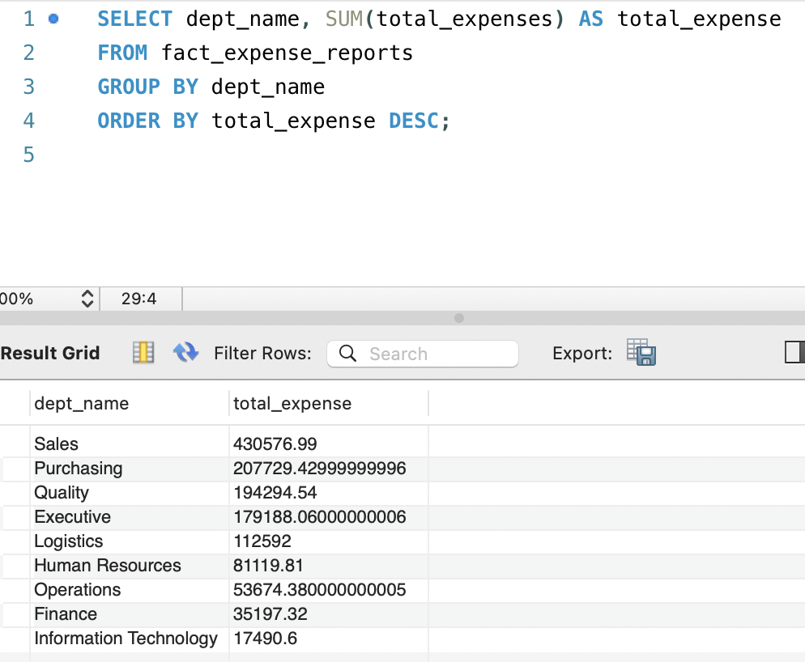

From this query, I found the total amount spent by each department.

**Question 2: Top 5 Employees with Highest Expenses.**

SELECT first_name, last_name, dept_name, total_expenses

FROM fact_expense_reports

ORDER BY total_expenses DESC

LIMIT 5;

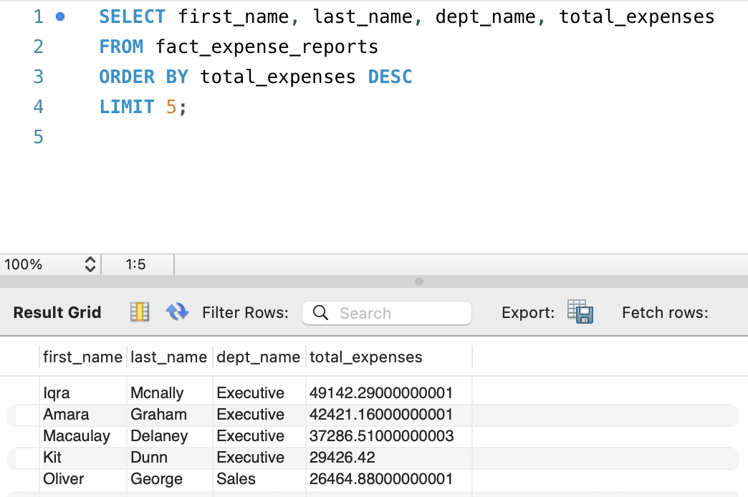

It identifies 5 employees who spent the most on trips.

**Question 3: Average Reimbursement by Department.**

SELECT dept_name, AVG(total_reimbursement) AS avg_reimbursement

FROM fact_expense_reports

GROUP BY dept_name

ORDER BY avg_reimbursement DESC;

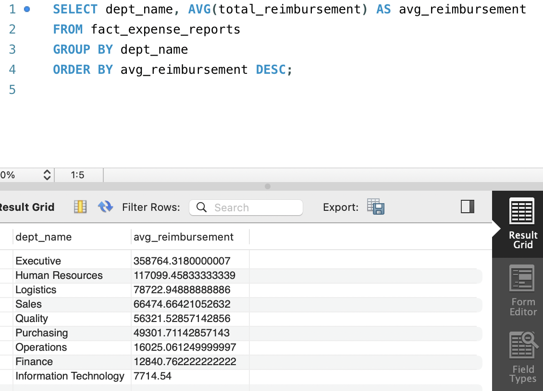

It finds departments with highest average reimbursements.

**Question 4: Most Frequent Trip Reasons with High Expenses.**

SELECT rc.reason_description, COUNT(t.trip_id) AS trip_count, SUM(ex.gross_amount) AS total_expense

FROM trips t

JOIN reason_codes rc ON t.reason_code = rc.reason_code

JOIN expenses ex ON t.trip_id = ex.trip_id AND t.employee = ex.employee

GROUP BY rc.reason_description

ORDER BY total_expense DESC

LIMIT 5;

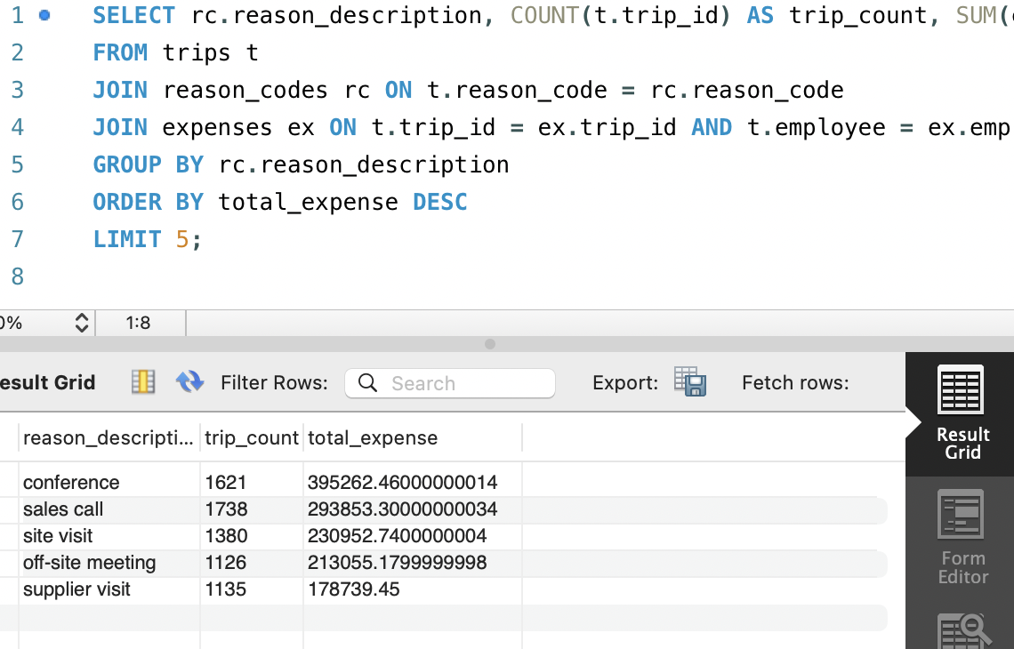

It finds top 5 trip reasons with highest spending.